Pizza Sales Analytics Problem Statement
You are tasked with analyzing a pizza sales dataset to uncover insights into customer orders, revenue generation, and product performance. The dataset contains information about orders, pizzas, categories, sizes, and prices. Your goal is to analysis three levels of complexity:
Basic Analysis
- Retrieve the total number of orders placed.
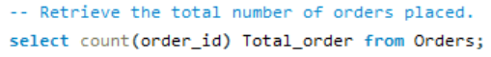
Output:
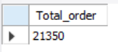
Definition: The count of all unique orders recorded in the dataset.
Business Insight: It reflects overall demand and customer activity. Managers use this to gauge sales volume, track growth, and forecast inventory needs.

- Calculate the total revenue generated from pizza sales.
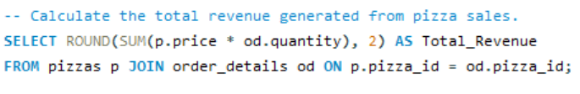
Output:
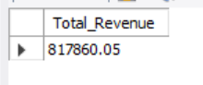
Definition: The sum of all sales amounts from pizzas sold.
Business Insight: It shows how much money the restaurant earned from pizza sales during the dataset period.
Use Case: Helps managers evaluate profitability, set sales targets, and identify growth opportunities.

- Identify the highest-priced pizza
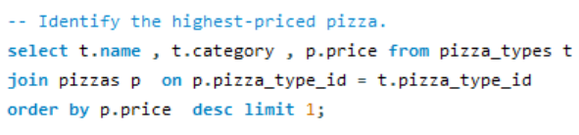Output:
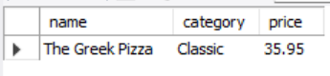
Definition: The pizza with the maximum unit price in the menu.
Business Insight: Identifies premium offerings that may appeal to niche customers or drive high-margin sales.
Use Case: Helps managers understand pricing strategy, evaluate whether premium pizzas are selling, and decide if luxury items should stay on the menu.

- Identify the most common pizza size ordered
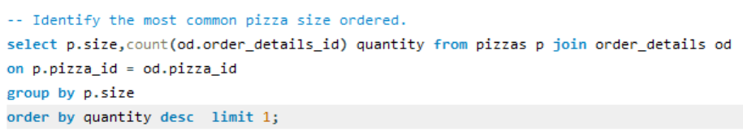
Output:
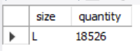
Definition: The pizza size (e.g., Small, Medium, Large, Extra Large) that appears most frequently in orders.
Business Insight: Reveals customer demand patterns and helps optimize inventory, pricing, and marketing strategies.
Use Case: If medium pizzas dominate, managers can focus promotions on that size or adjust stock levels accordingly.

- List the top 5 most ordered pizza types along with their quantities
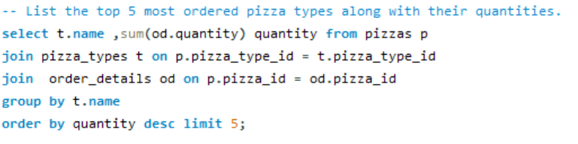
Output:
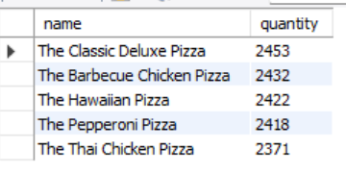
Definition: The five pizza types (e.g., Margherita, Pepperoni, BBQ Chicken) that were ordered the most, along with the total number of units sold.
Business Insight: Identifies customer favorites and helps managers focus on inventory, marketing, and promotions.
Use Case: If “The Classic Deluxe pizza” consistently ranks #1, the restaurant can ensure steady supply, run combo deals, or highlight it in advertising.

Intermediate Analysis
- Join the necessary tables to find the total quantity of each pizza category ordered.
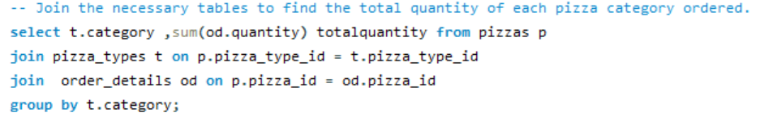
Output:
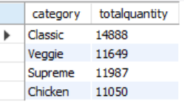
Definition: The sum of all pizzas sold, grouped by their category.
Business Insight: Shows which categories dominate sales volume.
Use Case: Helps managers understand customer preferences at a broader level (e.g., do people prefer meat-heavy pizzas or vegetarian options).

- Determine the distribution of orders by hour of the day
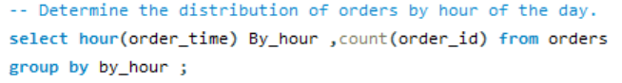
Output:
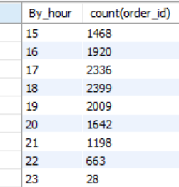
Definition: The count of orders grouped by the hour they were placed.
Business Insight: Reveals peak hours when customers are most likely to order pizzas.
Use Case: Helps managers plan staffing, kitchen prep, and marketing campaigns (e.g., lunch vs. dinner promotions).

- Join relevant tables to find the category-wise distribution of pizzas.
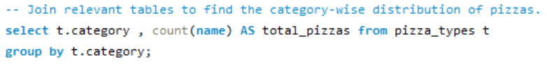
Output:
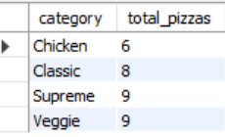
Definition: The breakdown of pizzas sold across categories such as Classic, Supreme, Veggie, Chicken.
Business Insight: Shows which categories dominate sales volume and which one’s lag.
Use Case: Helps managers decide whether to expand certain categories, adjust pricing, or run promotions.

- Group the orders by date and calculate the average number of pizzas ordered per day.
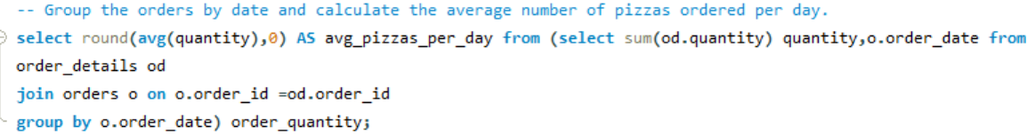
Output:
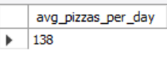
Definition: The mean number of pizzas sold per day across the dataset period.
Business Insight: Provides a baseline for daily sales expectations.
Use Case: Helps managers forecast inventory, plan staffing, and set realistic daily sales targets.

- Determine the top 3 most ordered pizza types based on revenue.
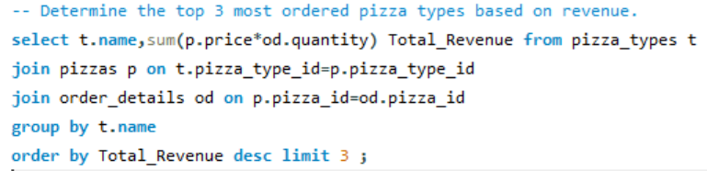
Output:
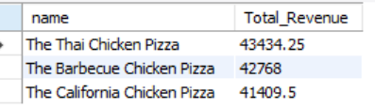
Definition: The three pizza types that generated the highest total revenue (quantity × price).
Business Insight: Identifies not just popular pizzas, but the ones that contribute most to the bottom line.
Use Case: Helps managers prioritize marketing, promotions, and inventory for high-earning pizzas.

Advanced Analysis
- Calculate the percentage contribution of each pizza type to total revenue.
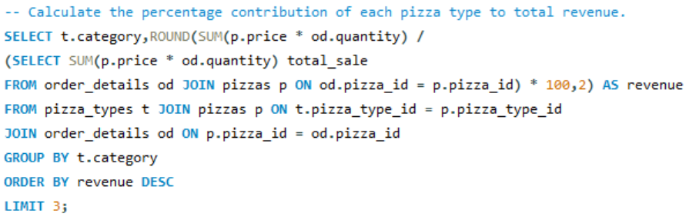
Output:
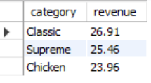
Definition: The share of total revenue generated by each pizza type, expressed as a percentage.
Business Insight: Highlights which pizzas are the biggest revenue drivers and which ones contribute marginally.
Use Case: Helps managers identify star products, evaluate menu performance, and decide where to focus promotions or discounts.

- Analyze the cumulative revenue generated over time.
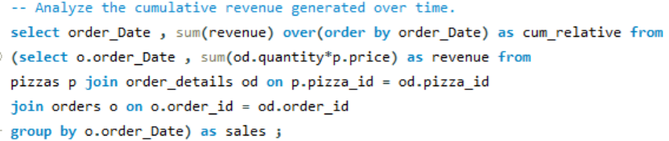
Output:
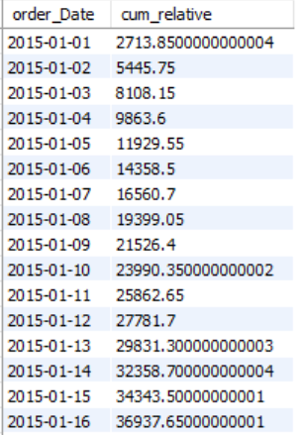
Definition: The running total of revenue, calculated day by day (or month by month), showing how sales accumulate over time.
Business Insight: Reveals growth trajectory, seasonality, and long-term performance.
Use Case: Helps managers track progress toward revenue targets, identify peak sales periods, and forecast future performance.

- Determine the top 3 most ordered pizza types based on revenue for each pizza category.
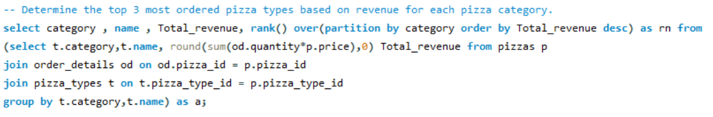
Output:
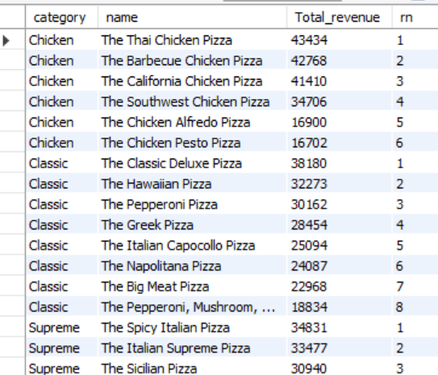
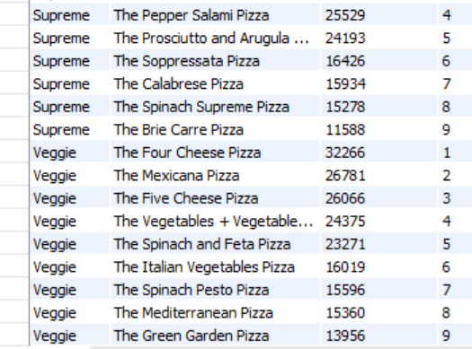
Definition: For each pizza category (e.g., Classic, Supreme, Veggie, Chicken), identify the three pizza types that generated the highest revenue.
Business Insight: Reveals the “star performers” within each category, helping managers understand which pizzas drive revenue in their respective segments.
Use Case: Guides menu optimization, targeted promotions, and inventory planning at the category level.

